DATABASE PRE-PROCESSING

1. What is Database Preprocessing?
Database preprocessing is the process of improving raw data quality stored in databases.
It involves:
- Cleaning incorrect data
- Handling missing values
- Removing duplicates
- Standardizing formats
- Transforming data
- Creating useful features
- Optimizing tables for analysis
The goal is:
- Better data quality
- Faster querying
- Accurate analytics
- Reliable machine learning models

2. Types of Databases
Relational Databases (SQL)
Examples:
- MySQL
- PostgreSQL
- Oracle Database
- Microsoft SQL Server
Structured tables:
- Rows
- Columns
- Relationships

NoSQL Databases
Examples:
- MongoDB
- Apache Cassandra
- Redis
Used for:
- Big data
- Semi-structured data
- Real-time systems

3. SQL Preprocessing Lifecycle:
Raw Data
↓
Data Cleaning
↓
Data Transformation
↓
Data Integration
↓
Feature Engineering
↓
Data Validation
↓
Optimized Analytical Dataset

4. Major Steps in SQL Preprocessing
A. Data Cleaning
Data cleaning improves data quality.
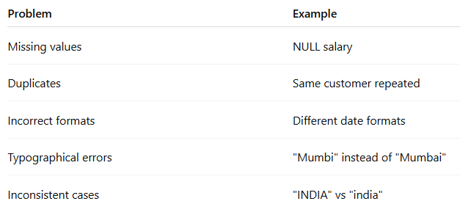

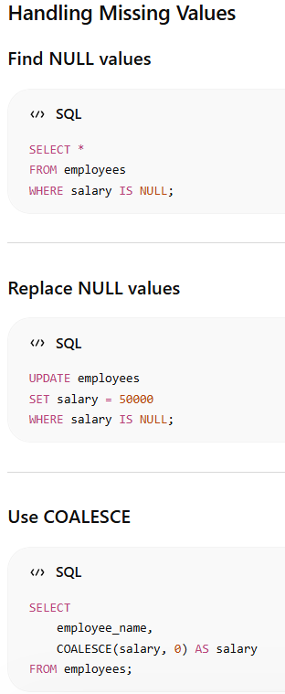

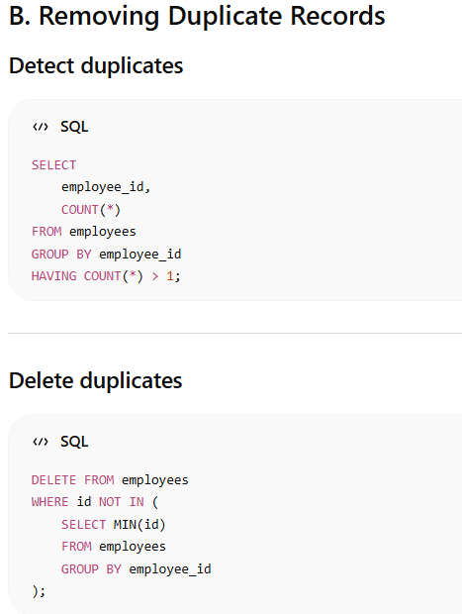
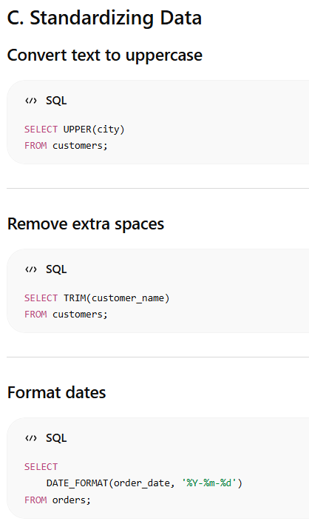

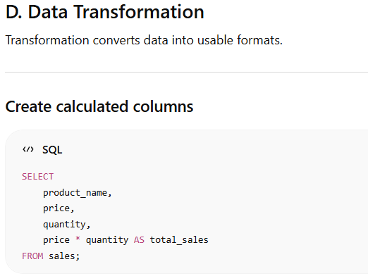
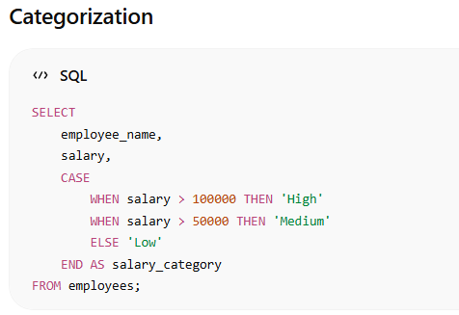

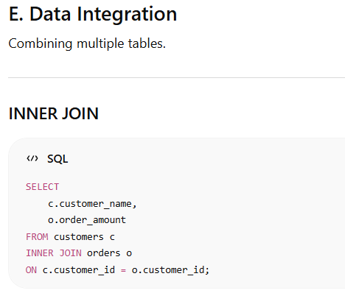

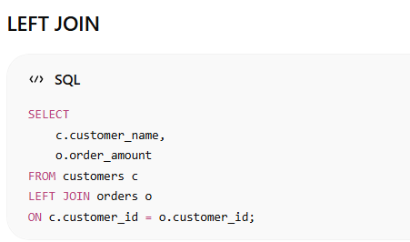

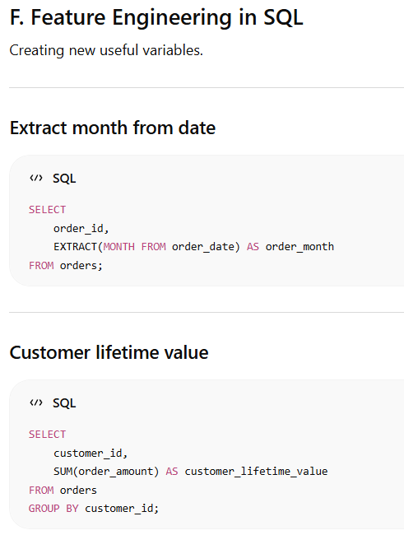
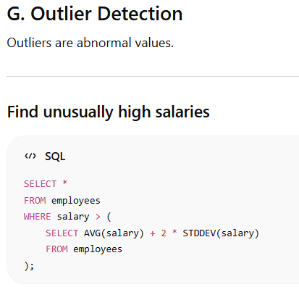

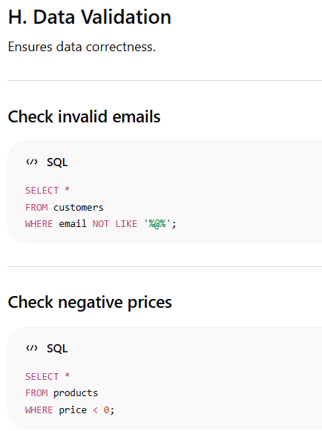
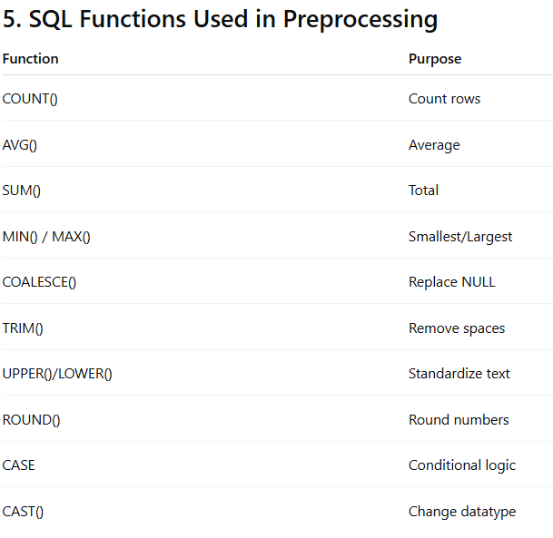

6. Normalization in Databases
Normalization removes redundancy.

First Normal Form (1NF)
Rules:
- No repeating groups
- Atomic values only

Second Normal Form (2NF)
Rules:
- Must be in 1NF
- Remove partial dependency

Third Normal Form (3NF)
Rules:
- Must be in 2NF
- Remove transitive dependency

7. Indexing for Faster Preprocessing
Indexes improve query performance.
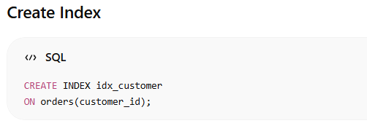

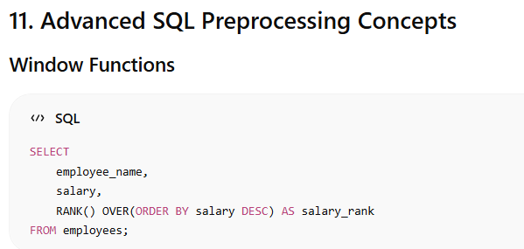

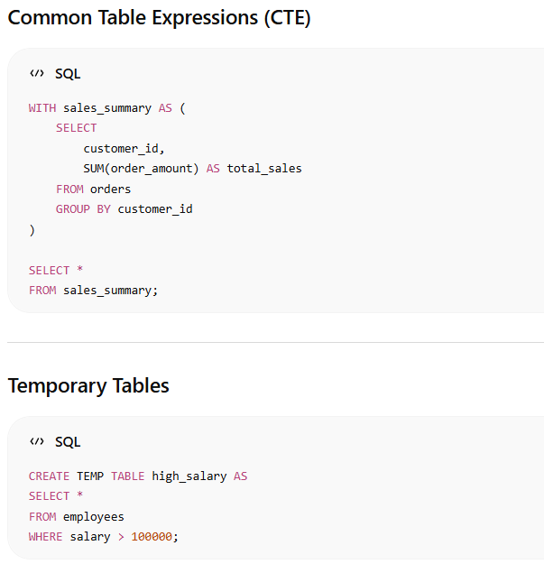

12. Data Warehousing Concepts
Important schemas:
- Star Schema
- Snowflake Schema
Fact table:
- Numerical metrics
Dimension table:
- Descriptive attributes

15. End-to-End SQL Preprocessing Workflow

- 1. Extract raw data
2. Handle NULL values
3. Remove duplicates
4. Standardize formats
5. Join tables
6. Create features
7. Validate data
8. Optimize queries
9. Load into warehouse
10. Use for analytics/ML

1. Difference Between DELETE, DROP, and TRUNCATE
These are SQL commands used to remove data or database objects, but they work differently.

A. DELETE
DELETE removes specific rows from a table.
- Can use WHERE
- Removes rows one by one
- Can rollback in transactions
- Table structure remains

